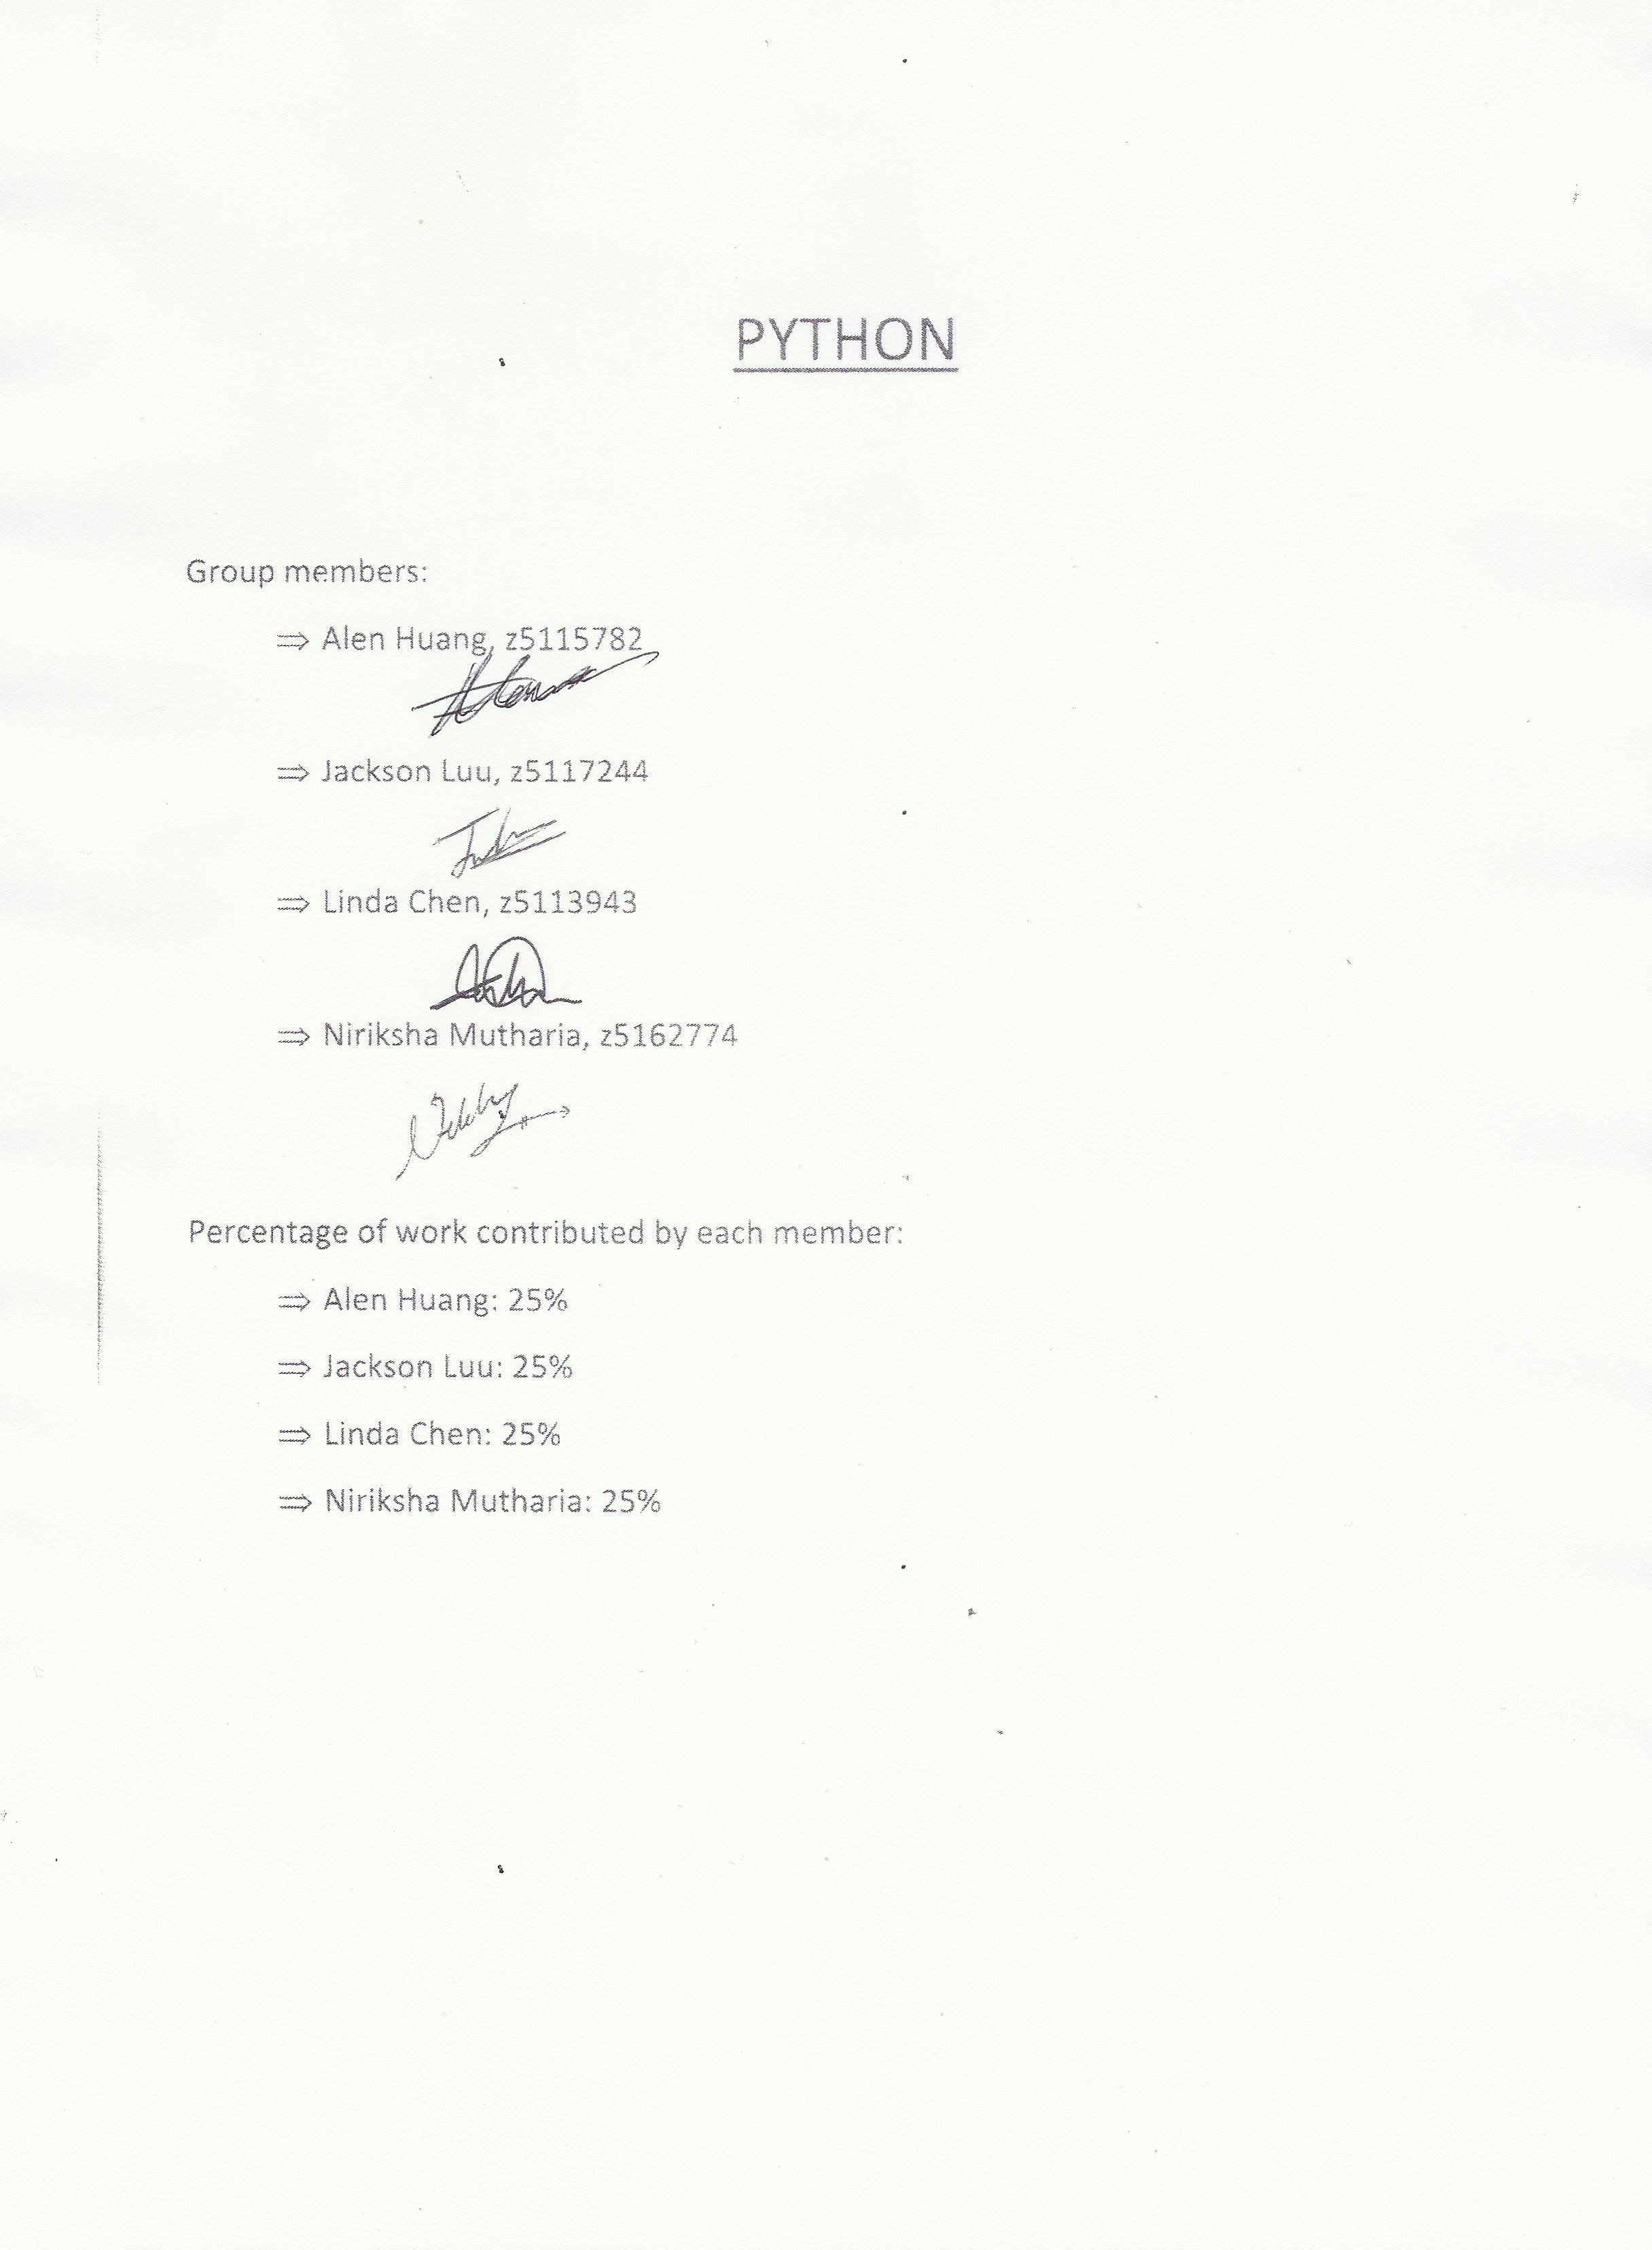

USER STORY – Final iteration

**EPIC STORY 1:** As an admin, I want to be able to create surveys in order to effectively collect feedback from students doing various course. The surveys should be a compilation of questions from the two pools; mandatory and optional. The responses are then collected in a database containing statistical data.

**EPIC STORY 2:** As a staff, I want to be able to review surveys, which are assigned to me, that the admin has created. I should be able to add/delete optional questions to/from the survey and make the survey open to the students currently undertaking the course. I should also be able to view the graphical results of survey after the survey’s closed.

**EPIC STORY 3:** As a student, I should be able to complete the surveys for the courses I am enrolled in which are shown on my dashboard. I should also be able to view the graphical results of survey after the survey’s closed.

*\*\*\*\* A single user point will equate to approximately 1 hour of work \*\*\*\**

List of user stories for the final iteration (including ones from previous iterations):

* **ID:** US1 – survey system should provide for three different types of users
* **ID:** US2 – strict authorisation
* **ID:** US3 – create a survey for a particular course
* **ID:** US4 – create two pools of questions (optional and mandatory)
* **ID:** US5 – admin can view all the survey questions
* **ID:** US6 – creating multiple choice questions
* **ID:** US7 – creating open ended questions
* **ID:** US8 – to set the duration of survey availability
* **ID:** US9 – produce a statistical report of the results
* **ID:** US10 – staff reviews the survey
* **ID:** US11 – student can choose a course from the list on the dashboard
* **ID:** US12 – student completes the survey for a particular course only once
* **ID:** US13 – database is used to store information
* **ID:** US14 – guest user completing the survey

**ID:** US1

**EPIC STORY:** 1, 2, 3

**USER STORY DESCRIPTION:** The survey system should provide for three different types of users (admin, student, staff) to accommodate their different roles.

**ACCEPTANCE CRITERIA:**

* There are different dashboards of each user that allows them to do or access different things;
* Admin: creating surveys, closing surveys
* Staff: reviewing created surveys, making them available to the students enrolled in the course, view the survey results
* Student: completing and submitting the survey, view the survey results
* Username and password are required to view the dashboard

**PRIORITY:** 10

**SIZE:** 10

**ID:** US2

**EPIC STORY:** 1, 2, 3

**USER STORY DESCRIPTION:** URL of a user’s dashboard can’t be used to open the dashboard again when logged in as a different user or not logged in at all for security reasons.

**ACCEPTANCE CRITERIA:**

* For example, when logged in as a student, the URL of the admin’s dashboard won’t be able to open the dashboard
* A suitable authorisation error is displayed if such behaviour is attempted

**PRIORITY:** 7

**SIZE:** 4

**ID:** US3

**EPIC STORY:** 1

**USER STORY DESCRIPTION:** As an admin, I want to be able to create a survey for a particular course so I can collect data on students’ views.

**ACCEPTANCE CRITERIA:**

* The admin can choose to create a survey for any of the courses provided
* The admin can add/delete questions from both pools into the survey
* The admin should be notified if they try to create a survey for a course that already exists

**PRIORITY:** 10

**SIZE:** 10

**ID:** US4

**EPIC STORY:** 1, 2

**USER STORY DESCRIPTION:** As an admin, I want to be able to create two pools of questions (optional and mandatory) so I can ask a diverse amount of questions.

**ACCEPTANCE CRITERIA:**

* Any combination of the questions from the pools may be included in the survey
* The admin can add/delete questions from both pools
* The staff can only add questions from the optional questions pool but not directly access the pool of questions

**PRIORITY:** 10

**SIZE:** 12

**ID:** US5

**EPIC STORY:** 1

**USER STORY DESCRIPTION:** As an admin, I would like to see all the questions that I have written so I can choose which ones to use when creating a new survey.

**ACCEPTANCE CRITERIA:**

* An admin should be able to view all the survey questions
* Admin should be able to select the question only once per survey
* When the admin has finished selecting the questions, they should be able to preview the survey before making it available to the staff
* If no question has been selected, and the admin proceeds with the creation of the survey, then an error message is displayed; “Select at least one question before creating the survey”
* If they can’t find a particular question, there should be an option for creating a new question on the same page

**PRIORITY:** 8

**SIZE:** 3

**ID:** US6

**EPIC STORY:** 1

**USER STORY DESCRIPTION:** As an admin, I should be able to choose how many answer options are allocated to each multiple choice question to allow respondents to respond more explicitly.

**ACCEPTANCE CRITERIA:**

* An option should be available for the admin to choose the number of answer options there are for each multiple question
* For convenience, the admin should be able to choose from yes/no option, option numeric/text rating, or they can have text based answer
* For the accuracy of results, the respondent can choose only one option from the multiple options present

**PRIORITY:** 9

**SIZE:** 6

**ID:** US7

**EPIC STORY:** 1

**USER STORY DESCRIPTION:** As an admin, I should be able to create questions which require text based answers from students

**ACCEPTANCE CRITERIA:**

* Questions that are open ended should have a text box below it to allow students to type their answer in

**PRIORITY:** 8

**SIZE:** 4

**ID:** US8

**EPIC STORY:** 1

**USER STORY DESCRIPTION:** As an admin, I should be able to set the duration of survey availability so there is a time limit in which students can complete the survey.

**ACCEPTANCE CRITERIA:**

* The admin determines when the closing date of the survey is
* When the survey is unavailable, the student won’t be able to attempt the survey i.e. the course of the survey is taken down from the student’s dashboard
* When the course is made unavailable, any responses that are in transit are to be ignored

**PRIORITY:** 6

**SIZE:** 6

**ID:** US9

**EPIC STORY:** 1

**USER STORY DESCRIPTION:** As an admin, I should be able to produce a statistical report of the results to better understand the collective views of students on a particular course offering.

**ACCEPTANCE CRITERIA:**

* Results are written to a database, depending on the course
* There should only be one database for each course
* Survey results stored in the system shouldn’t be affiliated with user to preserve anonymity
* The admin can view the results at any given time
* Students and staff can only view the survey results after the survey is closed
* The results cannot be modified by any of the three users

**PRIORITY:** 9

**SIZE:** 5

**ID:** US10

**EPIC STORY:** 2

**USER STORY DESCRIPTION:** As a staff, I should be able to review the surveys that have been made available to me by the admin so the students can complete the survey.

**ACCEPTANCE CRITERIA:**

* The staff can only add/delete questions in the survey that are from the optional question pool
* The staff shouldn’t be able to make any changes to the question pool themselves i.e. add/delete questions in the pool
* When the staff has finished reviewing the survey, they should be able to preview the survey before making it available to the students enrolled in the course

**PRIORITY:** 8

**SIZE:** 3

**ID:** US11

**EPIC STORY:** 3

**USER STORY DESCRIPTION:** As a student, I should be able to click on survey links on my dashboard for the courses I am taking so I can present my views on a particular course.

**ACCEPTANCE CRITERIA:**

* The respondents should be able to click on survey links on their dashboard and have the survey displayed to them
* Upon opening a survey, questions and answer options (if mcq) should be displayed
* Survey should be optimised for the respondent’s browser

**PRIORITY:** 10

**SIZE:** 5

**ID:** US12

**EPIC STORY:** 3

**USER STORY DESCRIPTION:** As a student, I can only complete the survey for a particular course offering once to prevent redundant data in the survey results.

**ACCEPTANCE CRITERIA:**

* The respondent should be able to select/type answers to the questions
* The respondent should be able to click submit in order to submit the survey
* The course name of the survey should be removed from the dashboard after the survey has been completed

**PRIORITY:** 10

**SIZE:** 3

**ID:** US13

**USER STORY DESCRIPTION:** A database is used to store information rather than csv for better storage system.

**ACCEPTANCE CRITERIA:**

* Databases are used to store the pools of questions, courses and staff afflicted with it, results of the survey

**PRIORITY:** 5

**SIZE:** 7

**ID:** US14

**USER STORY DESCRIPTION:** As a guest user, I wish to fill out survey for particular course-offerings so I can present my views on the course.

**ACCEPTANCE CRITERIA:**

* The guest needs to fill a registration form providing a user ID, password, and course offering of interest to be authorised by the admin
* Similar to a student, the course appears on guest’s dashboard if there is an open survey allocated to it
* The guest can only fill out the course once

**PRIORITY:** 1

**SIZE:** 5

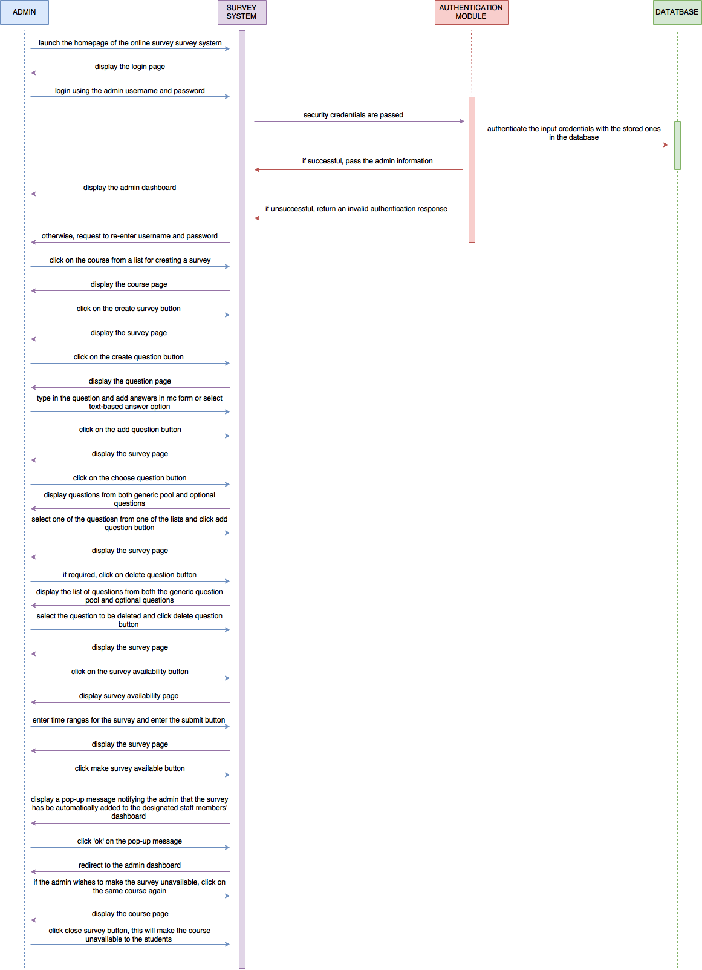SEQUENCE DIAGRAM – SURVEY CREATION BY ADMIN

SEQUENCE DIAGRAM – SURVEY REVIEW BY STAFF

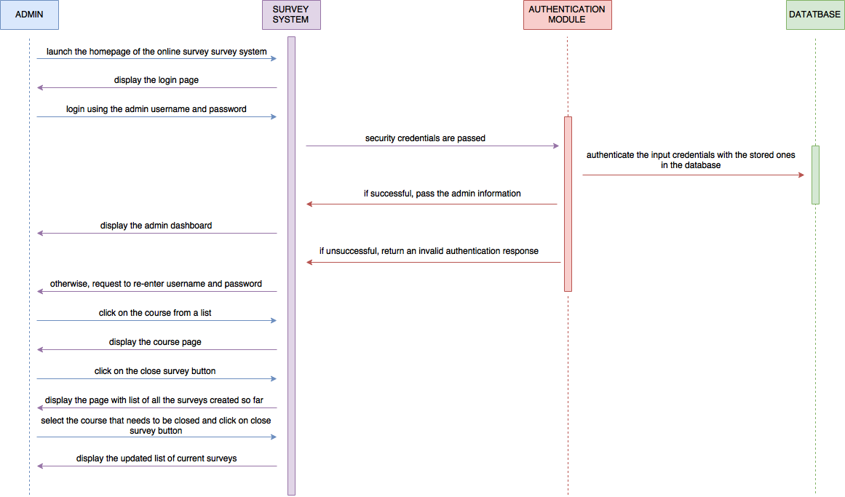

SEQUENCE DIAGRAM – SURVEY COMPLETION BY STUDENT

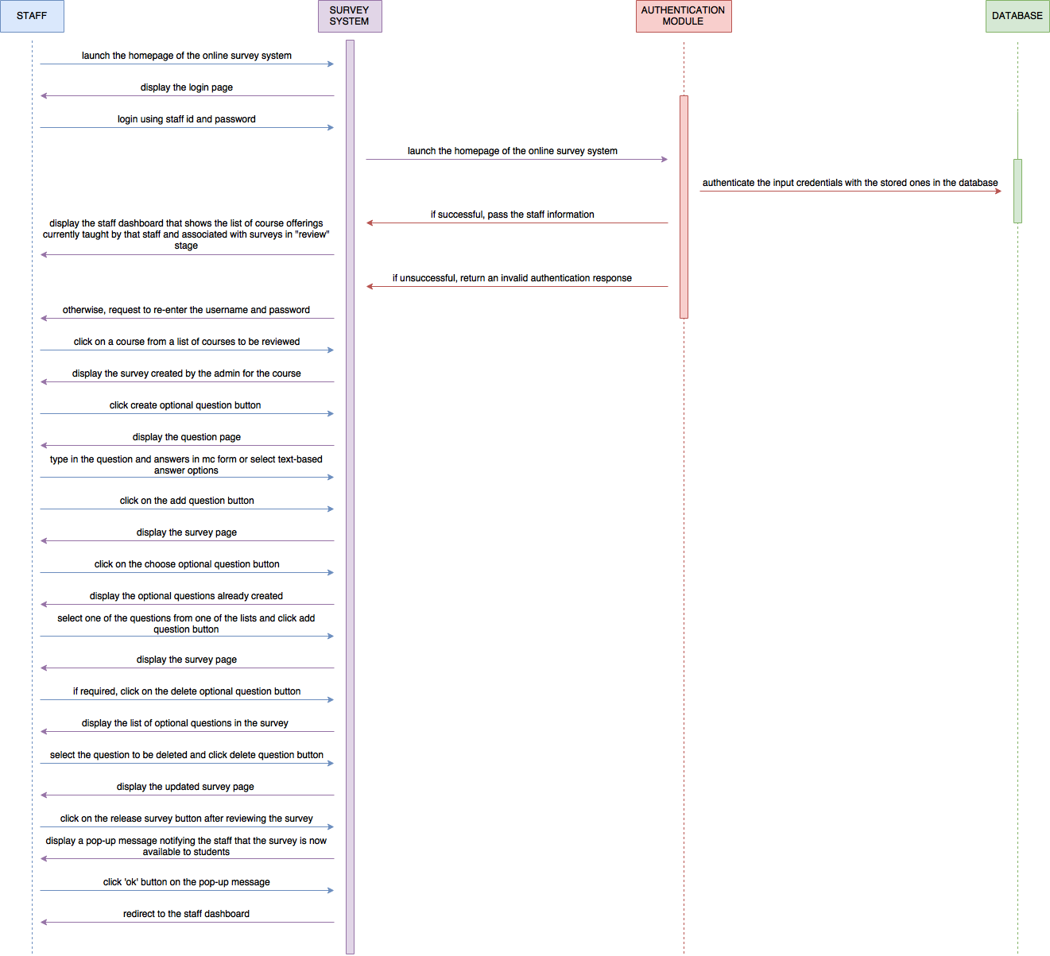

SEQUENCE DIAGRAM – SURVEY CLOSURE BY ADMIN

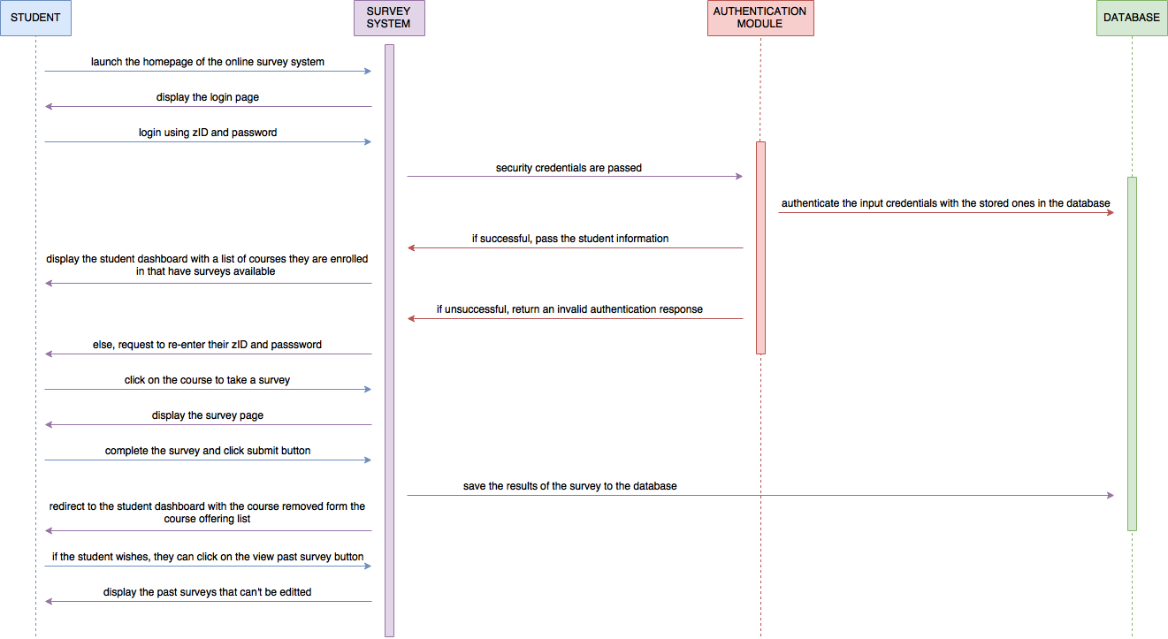

CLASS DIAGRAM

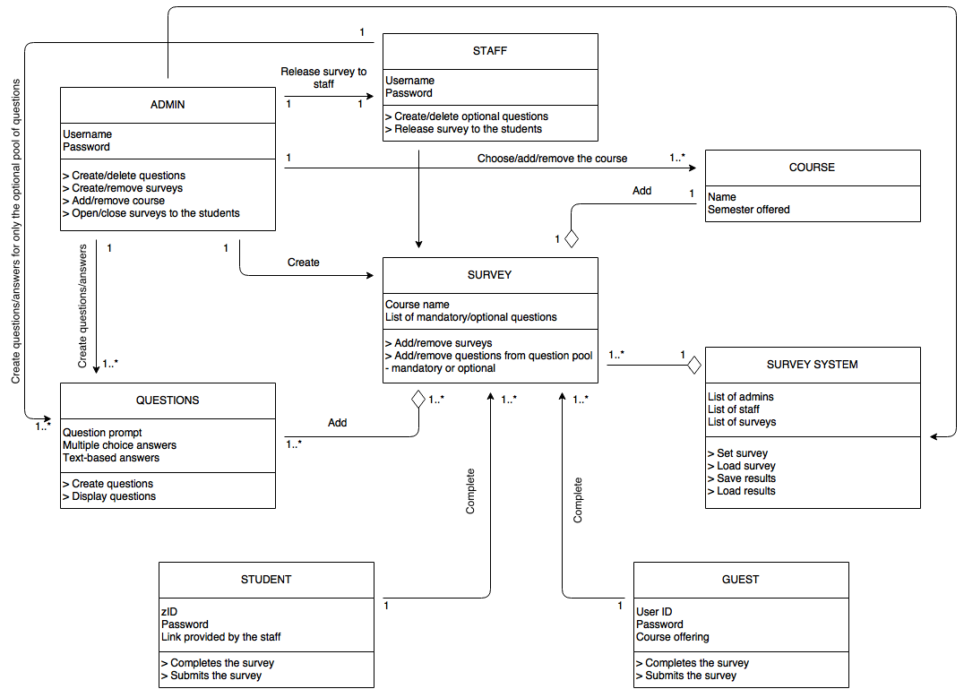

ER DIAGRAM

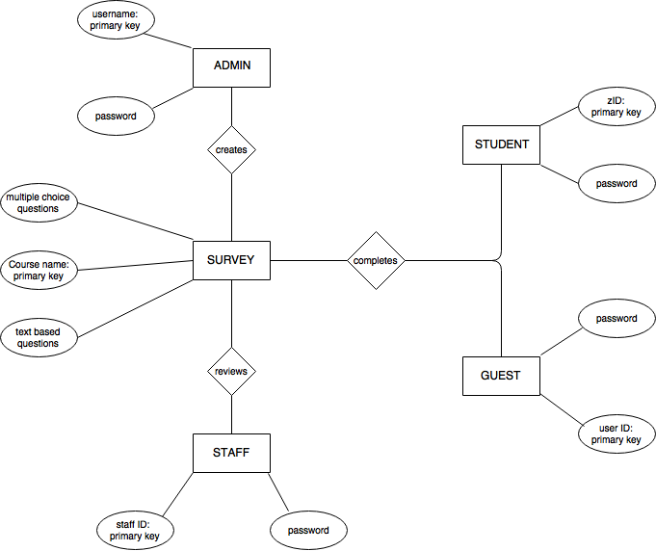

RESPONSIBILITIES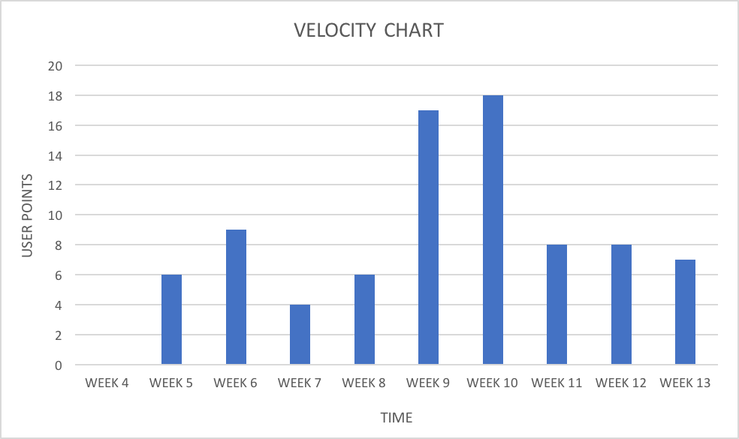:

Our team decided not to allocate specific responsibilities to the members rather we attempted the tasks that we could.

REFLECTION:

We are quite satisfied with our implantation of the survey system as it mostly behaves as it should, however, without a doubt there are a few errors that prevent the system from achieving all its goals. Given more time, there are some aspects of the system that could have been improved namely the usage of the question pool by the staff.

If we had to re-implement this application, the team would try to manage our time better so that instead of doing most of the work days before the iteration due date, we would try to maintain a consistent pace throughout the iterations. We will also try to have more stand-up meetings for better communication and to ensure everyone is on the same page. Nonetheless, the team is pretty content with our implementation of the survey system.